Supplymentary Material for
Increased Urban Thermal Discomfort in Major Cities of the Arabian Peninsula
Naushin Yasmin^{1,2}, Mirza Waleed^{1,2,3}, Safi Ullah^{1,2}, Sami Al-Ghamdi^{1,2*}
¹ Biological and Environmental Science and Engineering Division, Environmental Science and Engineering Program, King Abdullah University of Science and Technology (KAUST), Thuwal, Saudi Arabia.
² KAUST Climate and Livability Initiative, King Abdullah University of Science and Technology (KAUST), Thuwal, Saudi Arabia.
³ Department of Geography, Hong Kong Baptist University, Hong Kong SAR.

*Corresponding author's email: sami.alghamdi@kaust.edu.sa

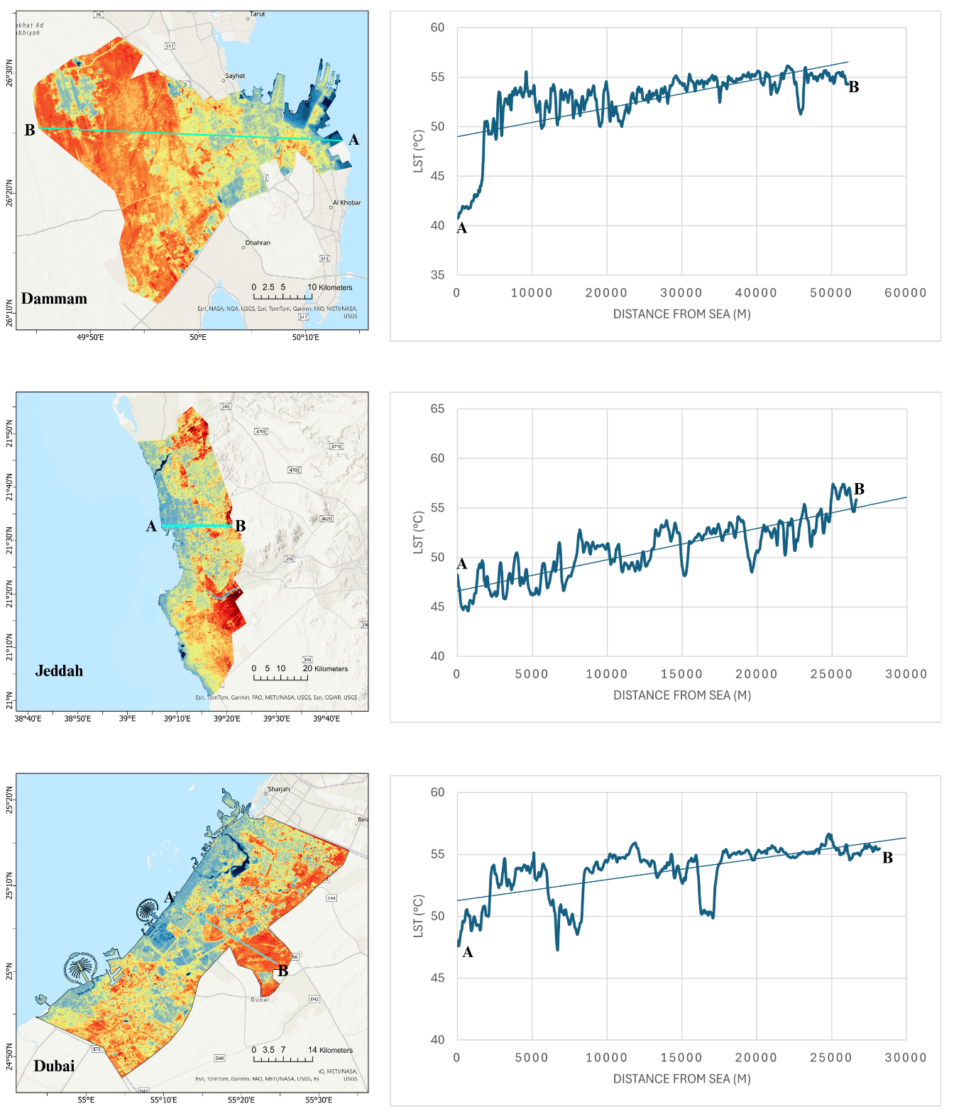
Figure S1. Spatial profile of the land surface temperature (LST) for Dammam, Jeddah, and Dubai.
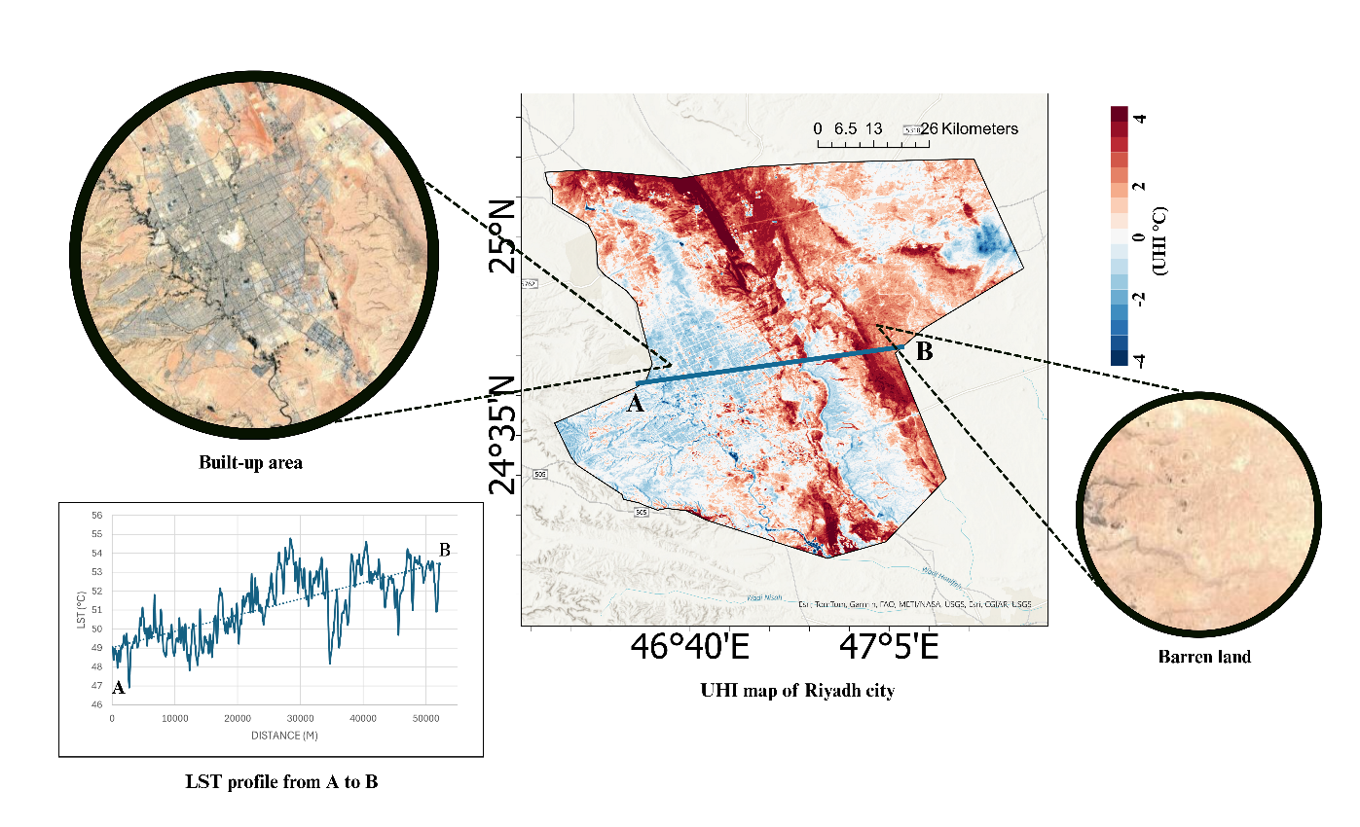
Figure S2. Spatial profile of urban heat island (UHI) effects for Riyadh city, with detailed land use and land cover distribution.
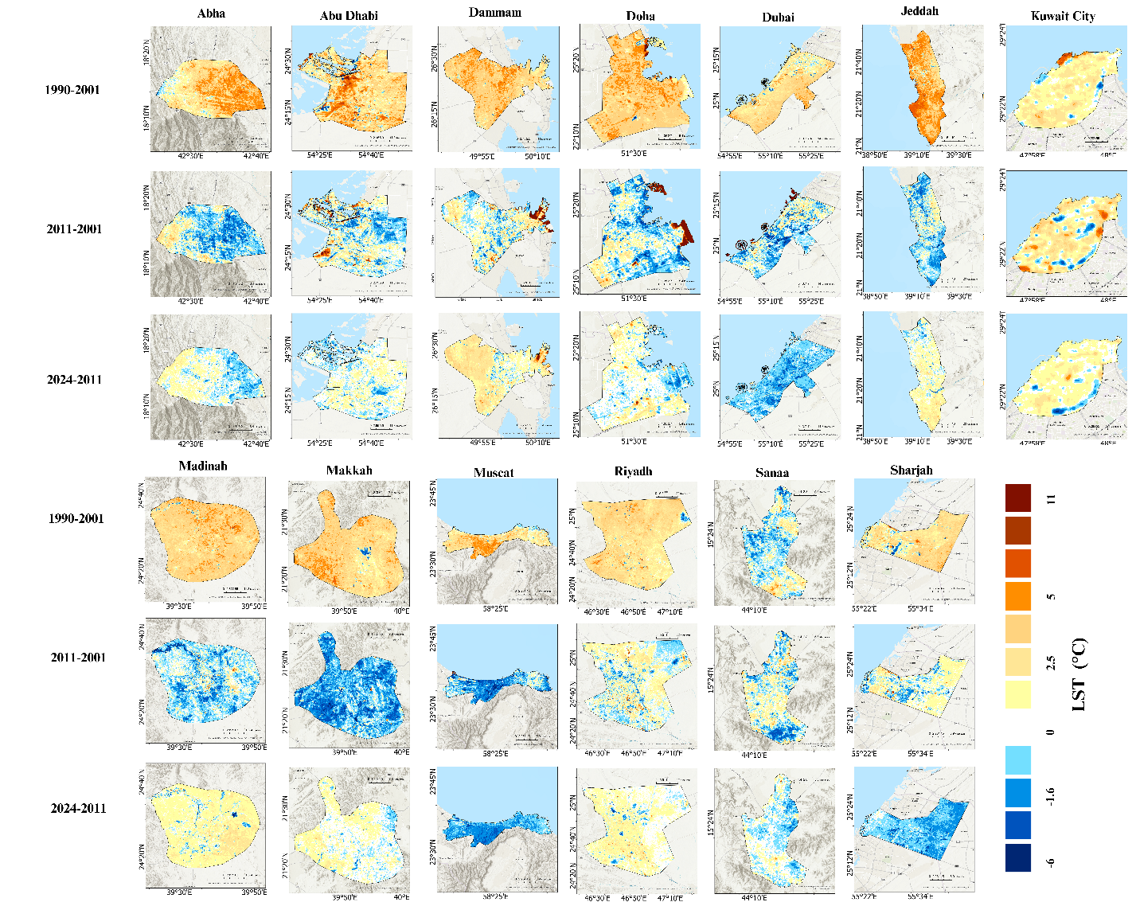
Figure S3. Spatiotemporal changes in LST across the 13 cities of the Arabian Peninsula (AP) during different epochs of the study period.
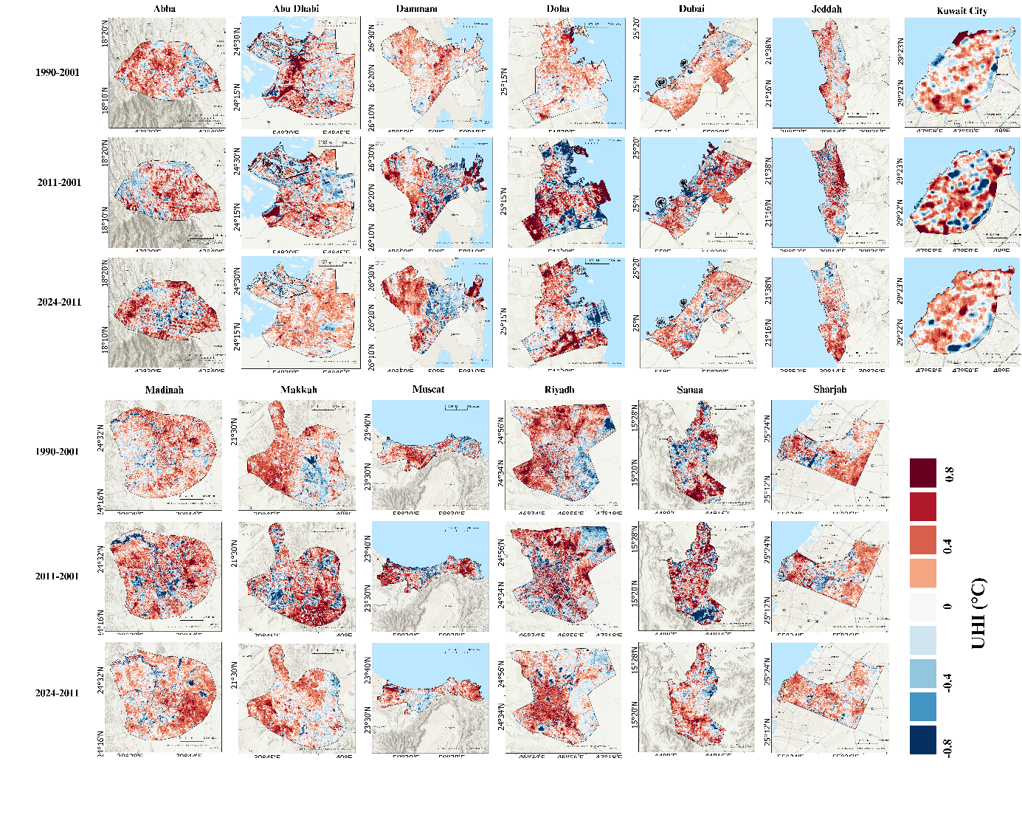
Figure S4. Spatiotemporal changes in UHI across the 13 cities of the AP during different epochs of the study period.
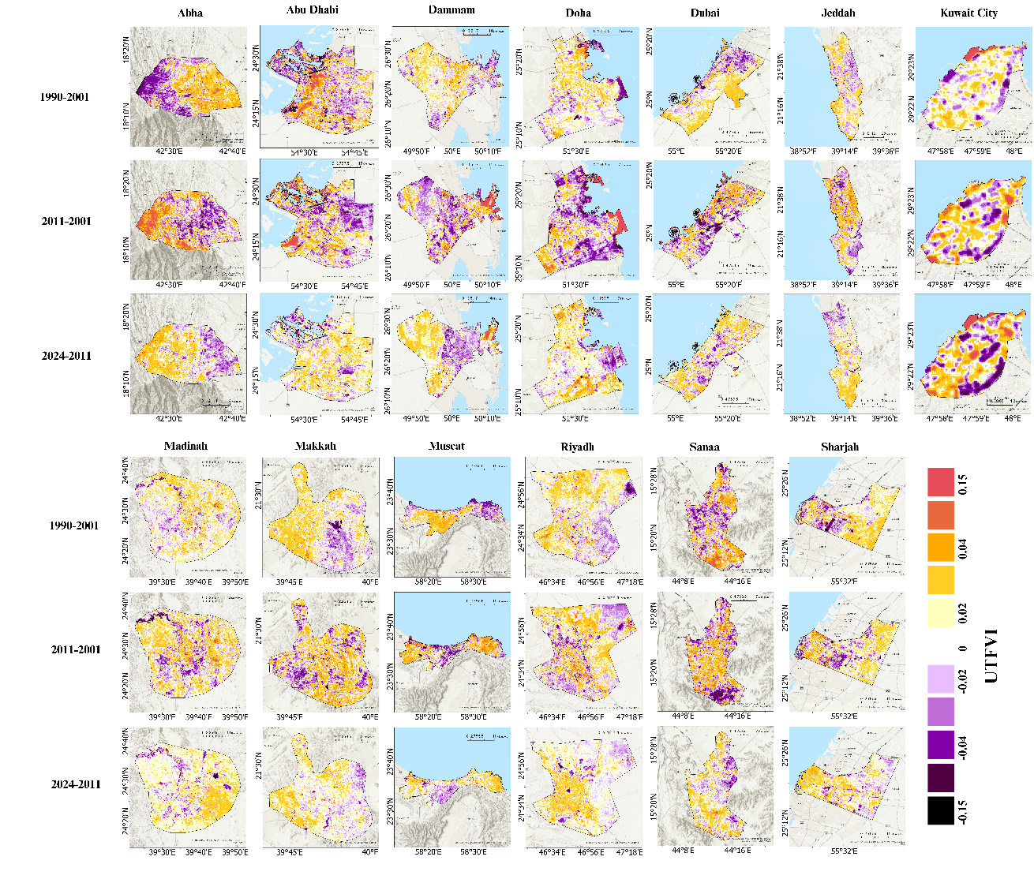
Figure S5. Spatiotemporal changes in urban thermal field variance index (UTFVI) across the 13 cities of the AP during different epochs of the study period.
Table S1. Area of different NDVI categories for the 13 cities in AP (all areas are in km²)
Year | Category | Abha | Abu Dhabi | Dammam | Doha | Dubai | Jeddah | Kuwait City | Madinah | Makkah | Muscat | Riyadh | Sanaa | Sharjah
1990–2000 | NDVI < -0.01 | 0.00 | 58.07 | 39.13 | 21.28 | 83.35 | 17.12 | 0.34 | 6.20 | 0.04 | 2.10 | 1.52 | 0.00 | 3.75
1990–2000 | 0.01 ≤ NDVI < 0 | 0.03 | 3.24 | 0.53 | 0.50 | 1.87 | 0.87 | 0.06 | 10.08 | 0.17 | 0.27 | 1.98 | 0.01 | 0.21
1990–2000 | 0 ≤ NDVI < 0.1 | 57.70 | 1753.37 | 1055.97 | 377.52 | 1637.77 | 2238.90 | 11.73 | 1712.92 | 710.14 | 251.80 | 7140.88 | 69.21 | 521.54
1990–2000 | 0.1 ≤ NDVI < 0.2 | 277.30 | 56.68 | 40.10 | 17.57 | 42.35 | 59.32 | 1.48 | 53.29 | 29.67 | 28.78 | 408.80 | 163.11 | 49.02
1990–2000 | 0.2 ≤ NDVI < 0.3 | 39.32 | 15.81 | 7.53 | 2.71 | 8.05 | 7.58 | 0.45 | 14.99 | 3.26 | 5.37 | 37.64 | 24.00 | 5.15
1990–2000 | 0.3 ≤ NDVI < 0.4 | 4.74 | 5.92 | 1.88 | 0.73 | 2.55 | 1.27 | 0.22 | 11.05 | 0.42 | 1.79 | 19.16 | 4.77 | 1.35
1990–2000 | 0.4 ≤ NDVI < 0.5 | 0.64 | 1.50 | 0.62 | 0.10 | 1.28 | 0.20 | 0.04 | 8.10 | 0.03 | 0.29 | 3.71 | 0.62 | 0.63
1990–2000 | 0.5 ≤ NDVI < 0.6 | 0.04 | 0.03 | 0.01 | 0.00 | 0.32 | 0.01 | 0.00 | 0.59 | 0.00 | 0.03 | 0.05 | 0.05 | 0.12
1990–2000 | NDVI >0.6 | 0.00 | 0.00 | 0.00 | 0.00 | 0.00 | 0.00 | 0.00 | 0.00 | 0.00 | 0.00 | 0.00 | 0.00 | 0.00
2001–2010 | NDVI < -0.01 | 0.04 | 53.17 | 38.96 | 19.68 | 82.00 | 17.18 | 0.28 | 6.79 | 0.97 | 1.90 | 5.32 | 0.01 | 3.18
2001–2010 | 0.01 ≤ NDVI < 0 | 0.05 | 4.44 | 1.79 | 1.69 | 6.07 | 5.61 | 0.12 | 10.04 | 2.31 | 0.42 | 7.42 | 0.01 | 0.67
2001–2010 | 0 ≤ NDVI < 0.1 | 167.99 | 1694.82 | 1055.41 | 379.13 | 1612.24 | 2224.59 | 10.82 | 1715.19 | 711.16 | 256.84 | 7341.06 | 71.07 | 540.17
2001–2010 | 0.1 ≤ NDVI < 0.2 | 190.10 | 97.61 | 38.31 | 15.20 | 54.52 | 64.87 | 2.08 | 47.31 | 25.05 | 24.65 | 194.07 | 157.18 | 28.83
2001–2010 | 0.2 ≤ NDVI < 0.3 | 17.66 | 30.45 | 8.02 | 3.11 | 12.16 | 10.13 | 0.69 | 14.79 | 3.49 | 4.96 | 36.66 | 25.01 | 6.04
2001–2010 | 0.3 ≤ NDVI < 0.4 | 3.17 | 11.21 | 2.41 | 1.04 | 6.49 | 2.17 | 0.31 | 11.72 | 0.65 | 1.51 | 20.56 | 6.99 | 2.29
2001–2010 | 0.4 ≤ NDVI < 0.5 | 0.69 | 2.68 | 0.71 | 0.49 | 3.45 | 0.57 | 0.05 | 9.76 | 0.09 | 0.13 | 6.96 | 1.36 | 0.58
2001–2010 | 0.5 ≤ NDVI < 0.6 | 0.06 | 0.25 | 0.15 | 0.08 | 0.55 | 0.09 | 0.00 | 1.51 | 0.01 | 0.00 | 1.63 | 0.14 | 0.02
2001–2010 | NDVI >0.6 | 0.01 | 0.00 | 0.00 | 0.00 | 0.00 | 0.00 | 0.00 | 0.01 | 0.00 | 0.00 | 0.04 | 0.00 | 0.00
2011–2020 | NDVI < -0.01 | 0.09 | 15.68 | 3.79 | 2.04 | 7.19 | 9.28 | 0.13 | 1.37 | 0.31 | 0.58 | 14.23 | 0.10 | 1.97
2011–2020 | 0.01 ≤ NDVI < 0 | 0.08 | 2.11 | 0.67 | 0.25 | 1.84 | 2.10 | 0.02 | 2.86 | 0.62 | 0.17 | 9.11 | 0.13 | 0.26
2011–2020 | 0 ≤ NDVI < 0.1 | 65.27 | 1464.46 | 1048.57 | 356.71 | 1224.49 | 2114.64 | 10.10 | 1588.95 | 675.23 | 212.26 | 5840.89 | 69.57 | 226.26
2011–2020 | 0.1 ≤ NDVI < 0.2 | 246.53 | 288.60 | 79.49 | 44.26 | 425.50 | 173.58 | 3.08 | 165.02 | 56.12 | 57.71 | 1658.84 | 161.16 | 314.71
2011–2020 | 0.2 ≤ NDVI < 0.3 | 55.34 | 68.97 | 8.88 | 9.32 | 73.40 | 18.43 | 0.75 | 21.91 | 8.54 | 10.72 | 52.84 | 21.24 | 22.70
2011–2020 | 0.3 ≤ NDVI < 0.4 | 10.22 | 29.68 | 3.02 | 4.05 | 25.68 | 4.73 | 0.22 | 15.33 | 1.98 | 4.75 | 21.93 | 6.86 | 9.69
2011–2020 | 0.4 ≤ NDVI < 0.5 | 1.99 | 15.04 | 1.02 | 2.03 | 11.96 | 1.99 | 0.03 | 14.11 | 0.52 | 3.02 | 11.38 | 2.23 | 4.51
2011–2020 | 0.5 ≤ NDVI < 0.6 | 0.24 | 7.10 | 0.32 | 1.32 | 6.12 | 0.51 | 0.00 | 7.46 | 0.40 | 1.17 | 4.41 | 0.46 | 1.55
2011–2020 | NDVI >0.6 | 0.01 | 2.97 | 0.01 | 0.44 | 1.37 | 0.01 | 0.00 | 0.23 | 0.00 | 0.05 | 0.11 | 0.02 | 0.14
2021–2024 | NDVI < -0.01 | 0.11 | 13.10 | 3.87 | 1.80 | 7.32 | 11.33 | 0.14 | 5.12 | 0.70 | 0.47 | 22.32 | 0.19 | 1.39
2021–2024 | 0.01 ≤ NDVI < 0 | 0.09 | 2.21 | 1.46 | 0.52 | 1.65 | 3.28 | 0.03 | 4.20 | 0.86 | 0.22 | 10.46 | 0.25 | 0.45
2021–2024 | 0 ≤ NDVI < 0.1 | 55.62 | 1410.75 | 980.80 | 326.99 | 991.57 | 1945.36 | 9.68 | 1490.86 | 645.46 | 192.15 | 5964.11 | 57.65 | 204.80
2021–2024 | 0.1 ≤ NDVI < 0.2 | 232.42 | 326.92 | 142.59 | 61.75 | 628.05 | 319.90 | 3.04 | 245.45 | 79.68 | 73.40 | 1524.25 | 148.27 | 328.33
2021–2024 | 0.2 ≤ NDVI < 0.3 | 68.81 | 72.45 | 11.18 | 14.63 | 98.84 | 28.39 | 0.85 | 25.22 | 11.71 | 13.41 | 53.96 | 41.64 | 28.17
2021–2024 | 0.3 ≤ NDVI < 0.4 | 18.16 | 34.95 | 3.93 | 6.93 | 30.38 | 8.52 | 0.37 | 16.41 | 3.01 | 6.12 | 20.96 | 9.27 | 12.20
2021–2024 | 0.4 ≤ NDVI < 0.5 | 3.85 | 17.96 | 1.37 | 3.94 | 12.75 | 4.34 | 0.16 | 15.21 | 1.17 | 3.68 | 10.64 | 3.51 | 4.95
2021–2024 | 0.5 ≤ NDVI < 0.6 | 0.66 | 10.48 | 0.47 | 2.67 | 6.08 | 2.94 | 0.05 | 13.10 | 0.59 | 0.96 | 6.28 | 0.87 | 1.38
2021–2024 | NDVI >0.6 | 0.06 | 5.81 | 0.11 | 1.21 | 0.90 | 1.21 | 0.00 | 1.63 | 0.55 | 0.02 | 0.74 | 0.10 | 0.11

Table S2. Area of different LST categories for the 13 cities in AP (all areas are in km²)
Year | Category | Abha | Abu Dhabi | Dammam | Doha | Dubai | Jeddah | Kuwait City | Madinah | Makkah | Muscat | Riyadh | Sanaa | Sharjah
1990–2000 | LST< 35 | 6.32 | 11.83 | 36.19 | 18.11 | 67.75 | 12.51 | 0.03 | 0.00 | 0.01 | 0.81 | 0.37 | 0.78 | 0.06
1990–2000 | 35 ≤ LST < 40 | 70.51 | 99.63 | 9.00 | 5.57 | 15.56 | 11.48 | 0.49 | 0.85 | 0.06 | 1.32 | 4.84 | 39.19 | 3.35
1990–2000 | 40 ≤ LST < 45 | 257.97 | 71.37 | 14.32 | 9.71 | 16.53 | 137.74 | 0.87 | 10.04 | 2.06 | 6.32 | 69.70 | 178.91 | 5.07
1990–2000 | 45 ≤ LST < 50 | 44.98 | 382.84 | 242.14 | 375.27 | 158.91 | 1270.31 | 6.02 | 100.12 | 94.06 | 108.84 | 3863.34 | 42.75 | 62.95
1990–2000 | 50 ≤ LST < 55 | 0.00 | 1309.22 | 844.08 | 11.75 | 1516.97 | 871.20 | 6.83 | 682.98 | 437.93 | 159.83 | 3671.17 | 0.14 | 326.97
1990–2000 | LST > 55 | 0.00 | 19.75 | 0.05 | 0.02 | 1.83 | 22.03 | 0.09 | 1023.25 | 209.61 | 13.31 | 4.32 | 0.00 | 183.39
2001–2010 | LST< 35 | 2.84 | 1.09 | 26.99 | 12.89 | 7.75 | 4.87 | 0.00 | 0.00 | 0.06 | 0.66 | 0.77 | 0.47 | 0.01
2001–2010 | 35 ≤ LST < 40 | 42.34 | 90.29 | 14.92 | 8.38 | 73.49 | 9.27 | 0.18 | 0.08 | 0.08 | 1.29 | 6.24 | 49.15 | 2.46
2001–2010 | 40 ≤ LST < 45 | 142.29 | 60.56 | 8.88 | 4.80 | 17.44 | 14.50 | 0.98 | 4.73 | 0.33 | 4.02 | 41.55 | 176.01 | 3.90
2001–2010 | 45 ≤ LST < 50 | 175.74 | 135.95 | 56.40 | 59.77 | 79.76 | 304.47 | 4.19 | 31.19 | 22.82 | 43.64 | 991.08 | 35.81 | 39.82
2001–2010 | 50 ≤ LST < 55 | 16.55 | 1186.39 | 672.83 | 333.15 | 748.28 | 1502.87 | 8.59 | 251.82 | 239.75 | 172.91 | 6210.92 | 0.32 | 138.97
2001–2010 | LST > 55 | 0.00 | 420.35 | 365.77 | 1.45 | 850.83 | 489.29 | 0.39 | 1529.42 | 480.69 | 67.91 | 363.19 | 0.00 | 396.63
2011–2020 | LST< 35 | 0.37 | 0.00 | 0.52 | 0.00 | 0.00 | 2.21 | 0.00 | 0.00 | 0.00 | 0.06 | 0.00 | 0.13 | 0.00
2011–2020 | 35 ≤ LST < 40 | 30.89 | 55.19 | 3.31 | 1.22 | 12.95 | 8.20 | 0.06 | 0.05 | 0.01 | 1.68 | 2.27 | 44.81 | 1.92
2011–2020 | 40 ≤ LST < 45 | 193.28 | 59.75 | 9.67 | 8.43 | 40.68 | 15.05 | 0.56 | 5.04 | 0.82 | 6.65 | 22.16 | 189.04 | 2.86
2011–2020 | 45 ≤ LST < 50 | 154.53 | 135.62 | 39.12 | 101.80 | 158.66 | 353.86 | 2.14 | 27.10 | 37.22 | 90.71 | 886.06 | 27.74 | 34.47
2011–2020 | 50 ≤ LST < 55 | 0.71 | 1241.48 | 657.77 | 308.46 | 946.11 | 1722.97 | 10.06 | 303.81 | 464.98 | 176.67 | 6013.38 | 0.05 | 152.23
2011–2020 | LST > 55 | 0.00 | 402.59 | 435.39 | 0.52 | 619.15 | 222.97 | 1.50 | 1481.24 | 240.71 | 14.66 | 689.87 | 0.00 | 390.31
2021–2024 | LST< 35 | 0.33 | 0.03 | 0.25 | 0.00 | 0.04 | 2.55 | 0.00 | 0.00 | 0.00 | 0.04 | 0.04 | 0.18 | 0.00
2021–2024 | 35 ≤ LST < 40 | 22.02 | 58.78 | 1.80 | 0.94 | 15.17 | 8.11 | 0.03 | 0.65 | 0.08 | 2.17 | 2.46 | 53.51 | 2.36
2021–2024 | 40 ≤ LST < 45 | 215.10 | 62.17 | 4.76 | 9.37 | 51.60 | 15.95 | 0.47 | 4.68 | 1.15 | 14.96 | 22.05 | 186.27 | 3.31
2021–2024 | 45 ≤ LST < 50 | 142.22 | 150.75 | 18.92 | 82.98 | 290.16 | 295.38 | 1.94 | 26.06 | 33.03 | 171.76 | 469.64 | 21.72 | 54.20
2021–2024 | 50 ≤ LST < 55 | 0.10 | 1172.11 | 421.46 | 326.84 | 1190.41 | 1671.18 | 9.09 | 208.92 | 418.95 | 98.74 | 6109.31 | 0.09 | 229.59
2021–2024 | LST > 55 | 0.00 | 450.80 | 698.59 | 0.30 | 230.18 | 332.11 | 2.80 | 1576.93 | 290.51 | 2.76 | 1010.24 | 0.00 | 292.33

Table S3. Area of different UHI categories for the 13 cities in AP (all areas are in km²)
Year | Category | Abha | Abu Dhabi | Dammam | Doha | Dubai | Jeddah | Kuwait City | Madinah | Makkah | Muscat | Riyadh | Sanaa | Sharjah
1990–2000 | UHI < -4 | 172.89 | 579.57 | 324.41 | 109.07 | 460.06 | 1076.37 | 6.08 | 729.57 | 351.82 | 140.57 | 3597.25 | 129.21 | 192.59
1990–2000 | -4 ≤ UHI < -2 | 6.91 | 45.37 | 25.30 | 19.99 | 44.85 | 61.21 | 0.31 | 36.36 | 14.52 | 7.88 | 225.38 | 4.76 | 23.81
1990–2000 | -2 ≤ UHI < 0 | 6.97 | 45.96 | 20.07 | 27.50 | 51.64 | 75.19 | 0.29 | 38.12 | 15.48 | 8.24 | 138.85 | 5.14 | 14.78
1990–2000 | 0 ≤ UHI < 2 | 17.18 | 121.04 | 76.35 | 37.83 | 154.34 | 125.43 | 0.57 | 86.23 | 29.68 | 16.45 | 403.65 | 9.68 | 41.65
1990–2000 | 2 ≤ UHI < 4 | 15.61 | 159.86 | 120.71 | 40.65 | 192.19 | 108.79 | 0.77 | 96.43 | 30.69 | 16.19 | 316.72 | 9.58 | 44.50
1990–2000 | UHI > 4 | 160.22 | 942.83 | 578.93 | 185.39 | 874.47 | 878.28 | 6.32 | 830.53 | 301.54 | 101.10 | 2931.89 | 103.38 | 264.46
2001–2010 | UHI < -4 | 178.17 | 512.29 | 339.68 | 118.18 | 533.42 | 1111.34 | 6.44 | 744.83 | 340.16 | 152.60 | 3606.03 | 126.83 | 208.13
2001–2010 | -4 ≤ UHI < -2 | 6.50 | 42.91 | 25.96 | 18.70 | 43.57 | 70.27 | 0.31 | 36.79 | 14.40 | 7.28 | 180.96 | 4.94 | 9.30
2001–2010 | -2 ≤ UHI < 0 | 6.41 | 51.15 | 32.79 | 19.99 | 52.34 | 68.08 | 0.38 | 38.74 | 14.74 | 5.90 | 183.34 | 5.18 | 10.89
2001–2010 | 0 ≤ UHI < 2 | 12.62 | 135.50 | 84.59 | 46.46 | 131.57 | 127.34 | 0.62 | 87.83 | 31.15 | 13.87 | 368.34 | 9.71 | 23.78
2001–2010 | 2 ≤ UHI < 4 | 12.25 | 191.47 | 117.44 | 48.02 | 158.39 | 113.58 | 0.62 | 94.90 | 31.94 | 12.06 | 361.62 | 10.37 | 33.47
2001–2010 | UHI > 4 | 163.83 | 961.31 | 545.33 | 169.08 | 858.26 | 834.65 | 5.97 | 814.15 | 311.35 | 98.71 | 2913.46 | 104.75 | 296.22
2011–20 | UHI < -4 | 183.92 | 624.11 | 428.79 | 179.05 | 681.99 | 1031.41 | 6.75 | 747.76 | 374.26 | 135.03 | 4000.78 | 133.74 | 221.96
2011–20 | -4 ≤ UHI < -2 | 6.06 | 50.41 | 18.02 | 14.30 | 35.29 | 66.49 | 0.32 | 38.52 | 11.87 | 6.13 | 131.48 | 4.76 | 8.56
2011–20 | -2 ≤ UHI < 0 | 6.09 | 47.75 | 23.48 | 14.74 | 40.04 | 64.57 | 0.28 | 42.28 | 20.13 | 6.48 | 189.44 | 4.62 | 14.55
2011–20 | 0 ≤ UHI < 2 | 12.15 | 113.95 | 48.62 | 22.06 | 76.17 | 136.93 | 0.59 | 88.21 | 31.21 | 13.98 | 291.44 | 9.05 | 23.46
2011–20 | 2 ≤ UHI < 4 | 12.66 | 136.71 | 58.42 | 29.05 | 94.64 | 135.69 | 0.66 | 94.28 | 29.59 | 14.14 | 284.77 | 9.04 | 30.17
2011–20 | UHI > 4 | 158.89 | 921.71 | 568.46 | 161.24 | 849.44 | 890.17 | 5.73 | 806.19 | 276.67 | 114.67 | 2715.83 | 100.55 | 283.09
2021–24 | UHI < -4 | 183.68 | 615.43 | 485.65 | 173.70 | 723.01 | 1019.72 | 6.97 | 743.03 | 356.96 | 134.80 | 4009.25 | 136.14 | 231.94
2021–24 | -4 ≤ UHI < -2 | 6.94 | 48.95 | 15.91 | 14.71 | 32.68 | 54.43 | 0.37 | 36.40 | 14.52 | 6.46 | 152.46 | 4.36 | 9.20
2021–24 | -2 ≤ UHI < 0 | 6.88 | 50.74 | 15.99 | 13.13 | 34.79 | 56.49 | 0.32 | 37.89 | 15.17 | 6.54 | 156.01 | 4.35 | 9.87
2021–24 | 0 ≤ UHI < 2 | 13.43 | 112.28 | 32.75 | 25.32 | 71.88 | 119.95 | 0.65 | 82.53 | 30.83 | 13.34 | 294.72 | 8.88 | 24.25
2021–24 | 2 ≤ UHI < 4 | 13.32 | 130.77 | 35.10 | 25.93 | 79.91 | 125.45 | 0.53 | 93.45 | 31.13 | 13.60 | 281.95 | 8.77 | 26.70
2021–24 | UHI > 4 | 155.53 | 936.47 | 560.38 | 167.64 | 835.29 | 949.21 | 5.49 | 823.95 | 295.13 | 115.67 | 2719.35 | 99.26 | 279.81

Table S4. Area of different UTFVI categories for the 13 cities in AP (all areas are in km²)
Year | Category | Abha | Abu Dhabi | Dammam | Doha | Dubai | Jeddah | Kuwait City | Madinah | Makkah | Muscat | Riyadh | Sanaa | Sharjah
1990–2000 | None (<0) | 172.89 | 579.57 | 324.41 | 109.07 | 460.06 | 1076.37 | 6.08 | 729.57 | 351.82 | 140.57 | 3597.25 | 129.21 | 192.59
1990–2000 | Weak (0-0.005) | 11.14 | 56.62 | 33.17 | 25.27 | 58.08 | 127.33 | 0.45 | 74.89 | 28.40 | 14.60 | 523.59 | 8.71 | 37.03
1990–2000 | Middle (0.005-0.010) | 11.49 | 65.76 | 35.00 | 28.91 | 77.79 | 121.19 | 0.44 | 87.68 | 29.54 | 15.08 | 486.77 | 8.70 | 38.54
1990–2000 | Strong (0.010-0.015) | 15.25 | 79.15 | 58.57 | 33.60 | 104.15 | 106.65 | 0.50 | 100.28 | 30.68 | 14.97 | 520.28 | 8.51 | 39.66
1990–2000 | Stronger (0.015-0.020) | 11.43 | 97.11 | 83.93 | 34.40 | 130.16 | 89.41 | 0.59 | 107.91 | 29.30 | 15.28 | 462.46 | 8.59 | 38.97
1990–2000 | Strongest (>0.020) | 157.57 | 1016.42 | 610.69 | 189.19 | 947.32 | 804.32 | 6.26 | 716.92 | 274.00 | 89.92 | 2023.40 | 98.05 | 234.99
2001–2010 | None (<0) | 178.17 | 512.29 | 339.68 | 118.18 | 533.42 | 1111.34 | 6.44 | 744.83 | 340.16 | 152.60 | 3606.03 | 126.83 | 208.13
2001–2010 | Weak (0-0.005) | 7.88 | 52.93 | 35.29 | 25.26 | 53.89 | 121.47 | 0.54 | 78.14 | 28.13 | 10.24 | 474.01 | 8.68 | 17.18
2001–2010 | Middle (0.005-0.010) | 7.95 | 66.58 | 43.55 | 28.99 | 70.74 | 109.20 | 0.49 | 91.74 | 30.44 | 9.37 | 479.32 | 8.29 | 18.77
2001–2010 | Strong (0.010-0.015) | 7.61 | 82.77 | 62.12 | 32.33 | 82.17 | 117.32 | 0.56 | 101.05 | 31.63 | 11.04 | 471.34 | 9.03 | 27.07
2001–2010 | Stronger (0.015-0.020) | 7.75 | 114.06 | 70.57 | 32.66 | 90.75 | 79.64 | 0.48 | 109.21 | 32.51 | 8.97 | 451.02 | 8.89 | 31.07
2001–2010 | Strongest (>0.020) | 170.42 | 1066.00 | 594.57 | 183.00 | 946.59 | 786.29 | 5.83 | 692.28 | 280.87 | 98.20 | 2132.02 | 100.04 | 279.57
2011–2020 | None (<0) | 183.92 | 624.11 | 428.79 | 179.05 | 681.99 | 1031.41 | 6.75 | 747.76 | 374.26 | 135.03 | 4000.78 | 133.74 | 221.96
2011–2020 | Weak (0-0.005) | 9.80 | 66.84 | 50.56 | 34.47 | 63.40 | 136.12 | 0.57 | 96.89 | 36.01 | 11.31 | 427.94 | 9.25 | 19.64
2011–2020 | Middle (0.005-0.010) | 9.28 | 75.98 | 59.08 | 35.72 | 70.89 | 142.99 | 0.54 | 104.73 | 34.94 | 11.88 | 385.42 | 8.99 | 21.74
2011–2020 | Strong (0.010-0.015) | 10.15 | 88.09 | 75.27 | 34.06 | 76.30 | 141.89 | 0.55 | 120.29 | 31.93 | 12.80 | 350.34 | 9.08 | 21.40
2011–2020 | Stronger (0.015-0.020) | 10.46 | 102.65 | 108.97 | 30.41 | 83.19 | 131.90 | 0.62 | 124.48 | 29.05 | 12.76 | 299.19 | 9.13 | 24.90
2011–2020 | Strongest (>0.020) | 156.17 | 936.96 | 423.11 | 106.72 | 801.79 | 740.95 | 5.30 | 623.10 | 237.54 | 106.65 | 2150.06 | 91.58 | 272.14
2021–2024 | None (<0) | 183.68 | 615.43 | 485.65 | 173.70 | 723.01 | 1019.72 | 6.97 | 743.03 | 356.96 | 134.80 | 4009.25 | 136.14 | 231.94
2021–2024 | Weak (0-0.005) | 12.38 | 67.09 | 36.11 | 35.99 | 56.91 | 109.16 | 0.62 | 81.40 | 32.72 | 12.61 | 397.66 | 8.47 | 17.20
2021–2024 | Middle (0.005-0.010) | 12.39 | 74.12 | 37.35 | 36.09 | 61.01 | 119.11 | 0.57 | 93.19 | 34.13 | 13.09 | 371.45 | 8.67 | 20.69
2021–2024 | Strong (0.010-0.015) | 12.29 | 81.66 | 41.64 | 34.08 | 67.05 | 125.80 | 0.49 | 106.72 | 34.30 | 13.50 | 356.71 | 8.67 | 22.85
2021–2024 | Stronger (0.015-0.020) | 12.42 | 91.27 | 54.90 | 31.73 | 74.20 | 133.05 | 0.50 | 114.70 | 34.18 | 13.33 | 330.46 | 8.85 | 25.63
2021–2024 | Strongest (>0.020) | 146.60 | 965.05 | 490.12 | 108.85 | 795.39 | 818.43 | 5.19 | 678.21 | 251.45 | 103.10 | 2148.21 | 90.95 | 263.48

