Supplementary Information for

On the Emergence of Geospatial Cloud-based Platforms for Disaster Risk Management: A Global Scientometric Review of Google Earth Engine Applications

Mirza Waleed¹, Muhammad Sajjad^{1, 2 *}
¹ Department of Geography, Hong Kong Baptist University, Hong Kong SAR
² Centre for Geo-computation Studies, Hong Kong Baptist University, Hong Kong SAR

*Corresponding Author Email (Muhammad Sajjad): mah.sajjad@hotmail.com
Address Corresponding Author: Office AAB-1222, Department of Geography, Office AAB-1222, Academic and Administration Building 224 Waterloo Rd, Kowloon Tong, Hong Kong Special Administrative Region.

  - Authors and Institutions evaluation
Collaborative networks depict the social connectedness of authors and their institutions in providing solutions to a specific research problem (Aria and Cuccurullo, 2017). Figure S1a shows the collaborative network of the top 50 authors based on the number of co-authored articles. This collaborative network forms ten research clusters highlighted by varying colors, among which four clusters (Blue, Red, Green, and Yellow) are the most significant (i.e., having collaboration links greater than 4). Among these, the blue cluster shows Youmin Zhang as the most prominent author, with eight collaborations among 15 collaborators. In the red cluster, Wang J leads among 8 researchers with a total 7 co-authored articles. In the Green cluster, Li Z achieved 6 collective network links, of which 3 were with blue and 1 with red clusters. Lastly, in the orange cluster, Wu Q and Amani M lead others with 5 and 3 articles, respectively.
In order to highlight the most productive authors in the field of disaster risk assessment and GEE, their article frequency (article published per year) and annual citations were analyzed individually. Figure S1b shows the most productive authors through annual publication frequency, whereas Figure S1c shows authors annual production through cumulative citations. Among the top 10 productive authors, Zhang Y showed the highest and most consistent publications (8 articles in 2022) (Figure 6b). Whereas, based on citation trends, DONG J showed the highest citation records (368 citations in 2016, and 220 citations in 2017, Figure S1c). Additionally, from both article frequency and citations (Figure 6b and c), it is evident that a major upsurge in research was carried out after 2019, in which 2020-2022 period might be considered the most productive in terms of authors productivity. These findings signify the contributions of specific authors (i.e., Zhang Y and DONG J) in advancing knowledge and understanding in the domain of disaster risk assessment and highlight the importance of their work in shaping the research landscape.
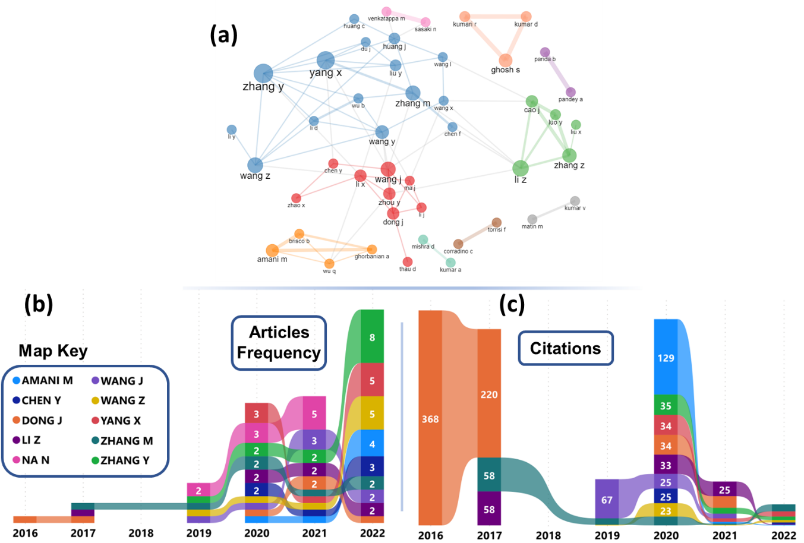
Figure S1 Authors collaboration network (a) (n=50), Authors productivity through articles frequency (b) and Authors productivity through citations count (c) (top 10 authors are considered in (b) and (c))
Figure S2a shows the top 50 institutes' collaborative network, in which 8 major clusters show the diversity of research carried out by mutual efforts of various institutions. Among these, the University of Chinese Academy of Sciences (UCAS) has the highest number of collaborative links highlighted in red color. Most of UCAS collaborative links are from its sub-institutes, including (i) the Institute of Remote Sensing and Digital Earth (RADI), (ii) the Aerospace Information Research Institute (AIRCAS), and (iii) the Institute of Geographic Sciences and Natural Resource Research (IGNSRR). In the blue cluster, the University of Tehran, Islamic Azad University, University of Twente, and Asian Institute of Technology have the most prominent collaborative links. Figure S2b shows annual production of each institute (by article frequency). In general, previously mentioned sub-institutes of UCAS (RADI, AIRCAS, and IGNSRR) dominate again as compared with other institutes. Among these sub-institutes, UCAS leads with 20 and 40 articles in 2020 and 2022, respectively. On the contrary, IGNSRR stood second with 29 and 37 articles in 2021 and 2022, respectively. These findings underscore the importance of collaboration and the role of specific institutions, such as UCAS and its sub-institutes, in driving research advancements and knowledge dissemination in geospatial cloud-based platforms for disaster risk management.
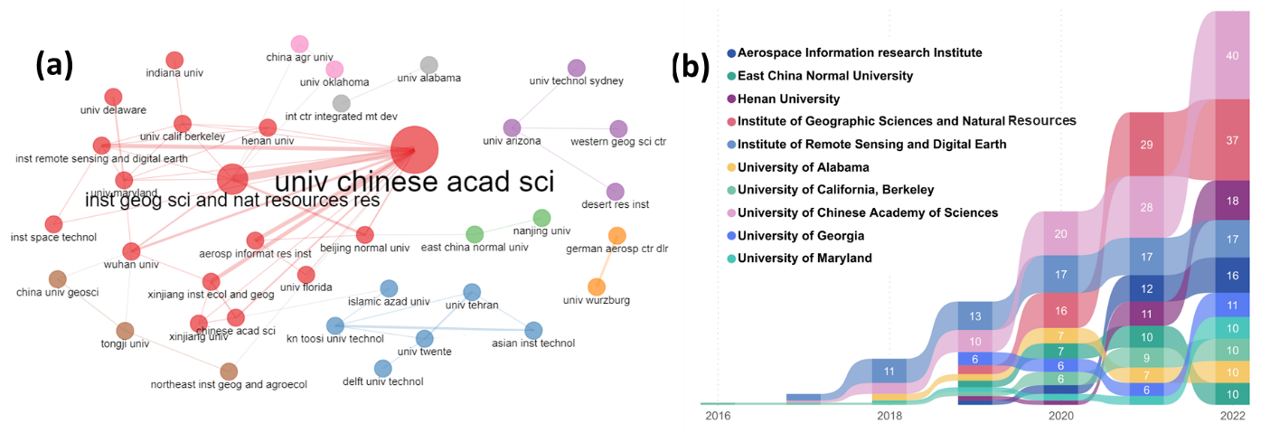
Figure S2 Institutes collaborative network (a) and Institution production annually (b)

